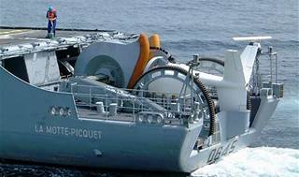

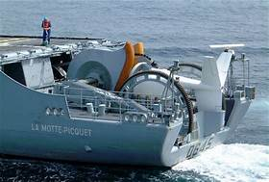

Explore

[**Sonar**, short for **SOund NAvigation and Ranging**, is a technique used to detect and determine the distance and direction of underwater objects by analyzing sound waves emitted by or reflected from those objects](https://www.sonarsource.com/open-source-editions/sonarqube-community-edition/) [1](https://www.sonarsource.com/open-source-editions/sonarqube-community-edition/)[2](https://www.sonarsource.com/open-source-editions/)[3](https://www.sonarsource.com/learn/).

Here are **five free reference links** where you can learn more about sonar:

1. [**Britannica**](https://www.britannica.com/technology/sonar): Provides an overview of sonar, its history, and its various applications.
2. [**NOAA Ocean Exploration**](https://oceanexplorer.noaa.gov/technology/sonar/sonar.html): Explains how scientists use sonar to explore the ocean, create nautical charts, and locate underwater hazards.
3. [**Discovery of Sound in the Sea**](https://dosits.org/galleries/technology-gallery/locating-objects-using-sonar/sonar/): Offers insights into sonar technology, including how it senses the location of objects in the ocean.
4. [**SonarQube Community Edition**](https://www.sonarsource.com/open-source-editions/sonarqube-community-edition/): SonarQube provides a workflow-integrated solution for maintaining clean code. Explore this free and open-source tool to improve code quality.
5. [**Sonar Developer Fundamentals**](https://www.sonarsource.com/learn/): Dive into core topics related to Clean Code, code quality, security, and DevOps CI/CD workflows.

Feel free to explore these resources to enhance your understanding of sonar technology! 🌊🔍